- Create a database named AirCargo and import ticket_details.csv, routes.csv, passengers_on_flights.csv, and customer.csv from the given resources into it.

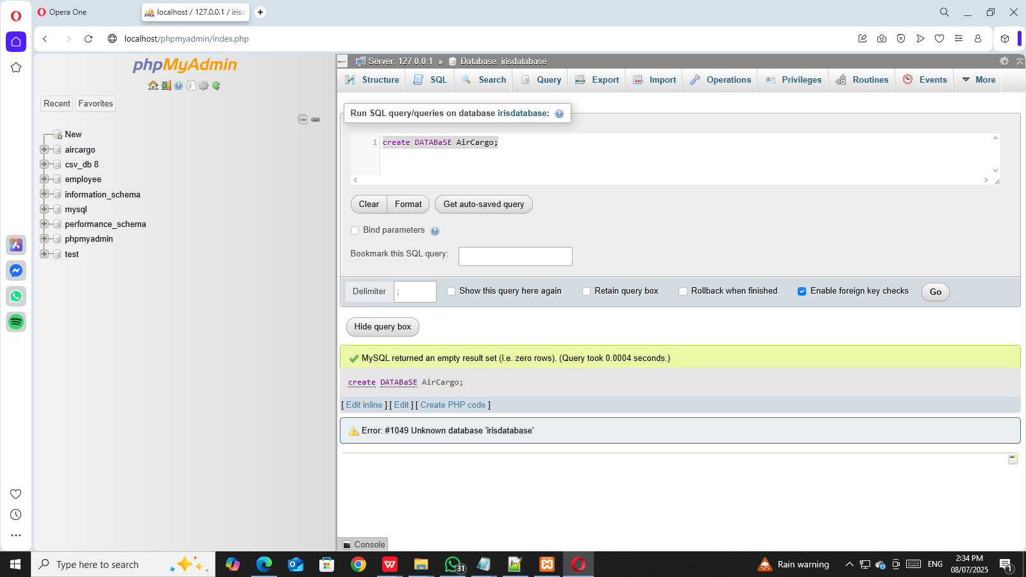

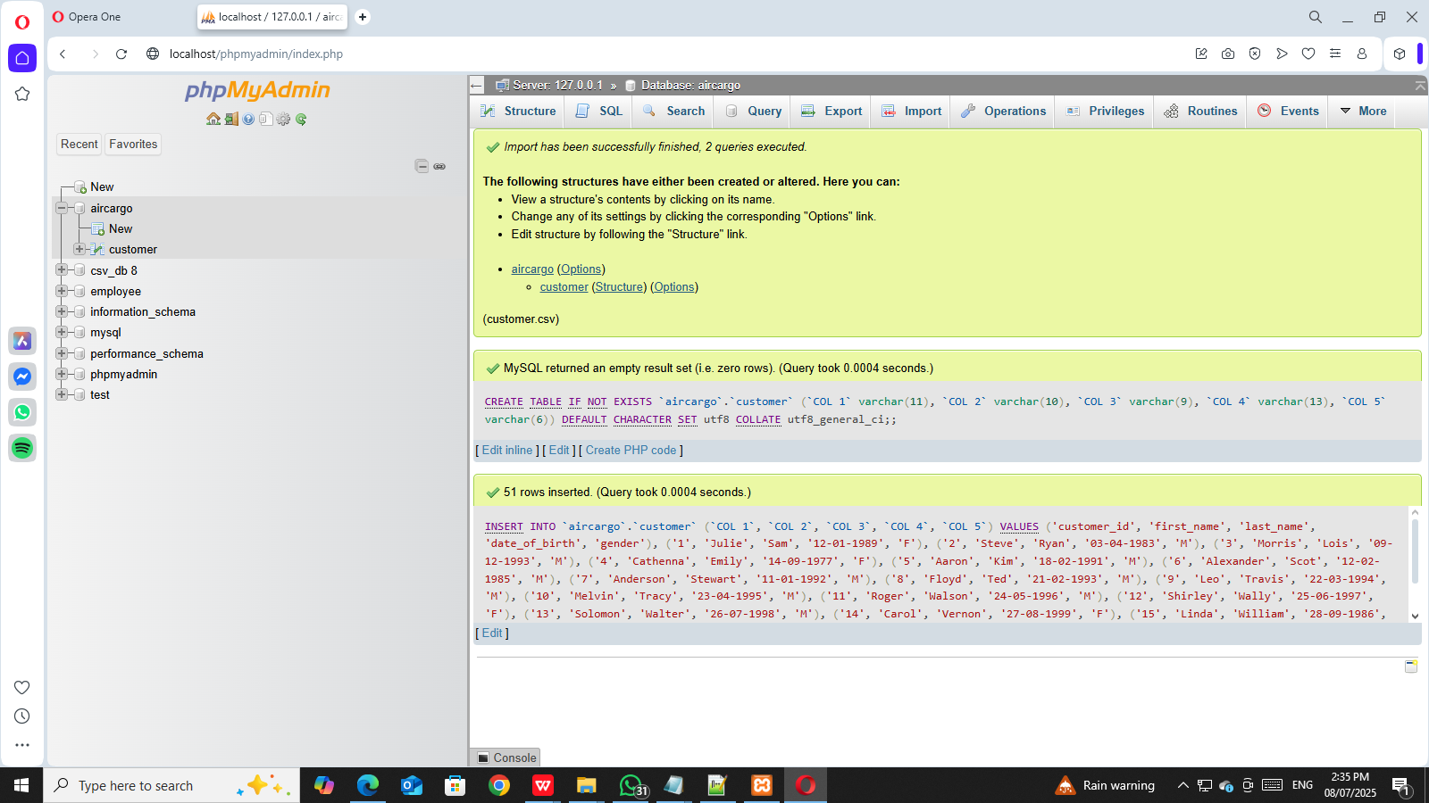

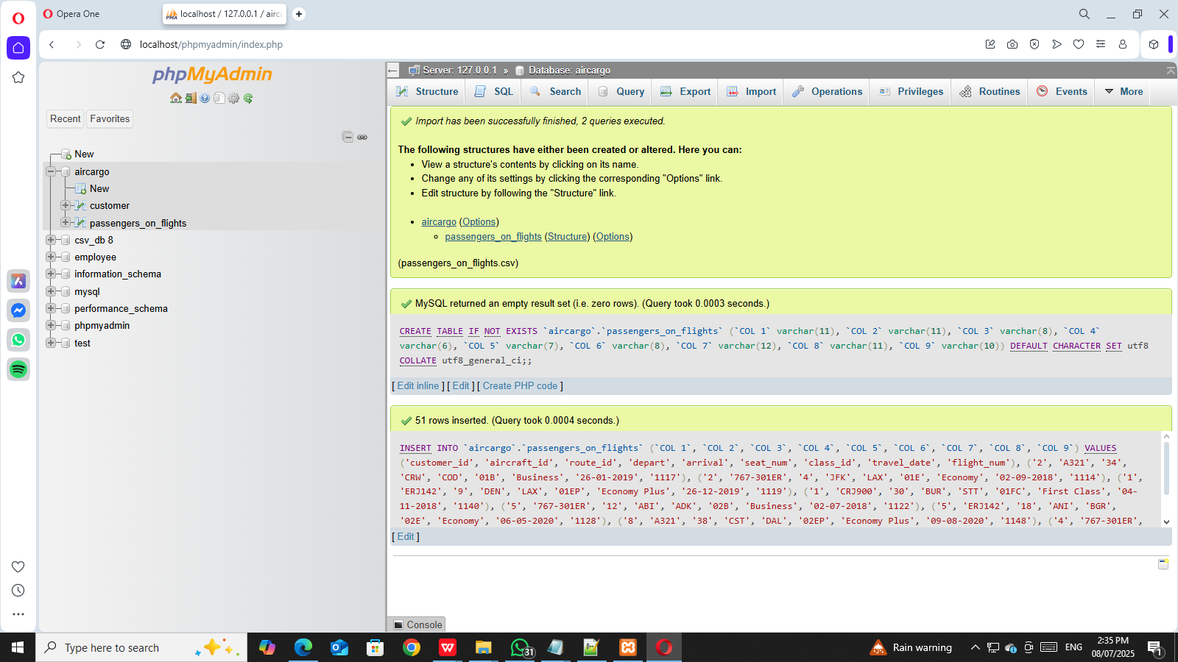

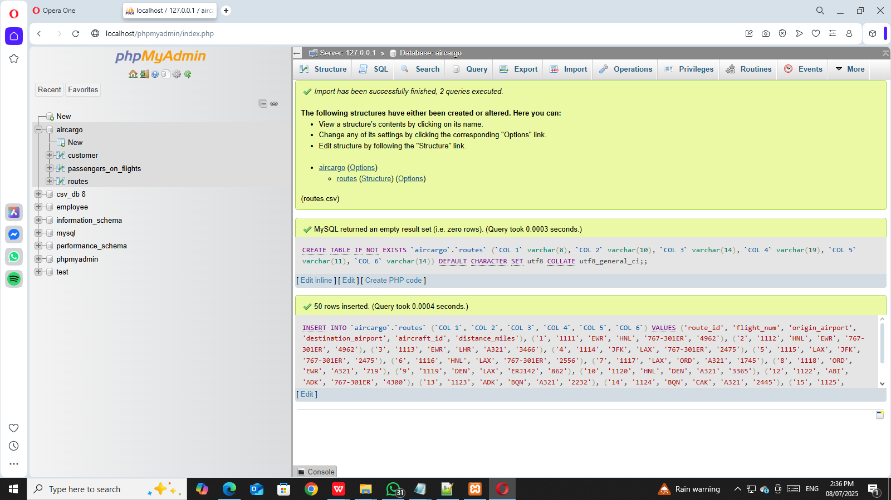

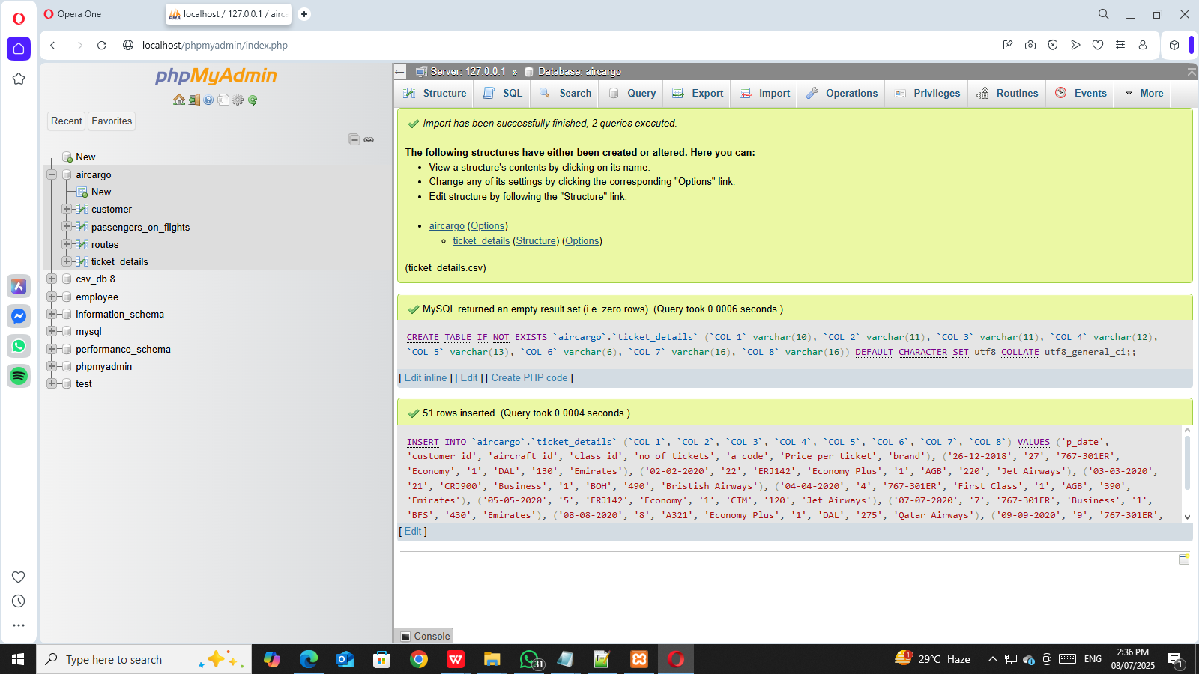

- Create an ER diagram for the given airlines' database.

- Write a query to display all the passengers who have traveled on routes 01
to 25 from the passengers_on_flights table.

